Registering in the WebGrants System

Enter the URL for WebGrants: https://agriculturegrants.vermont.gov

On the login page, click on Click here to Register.

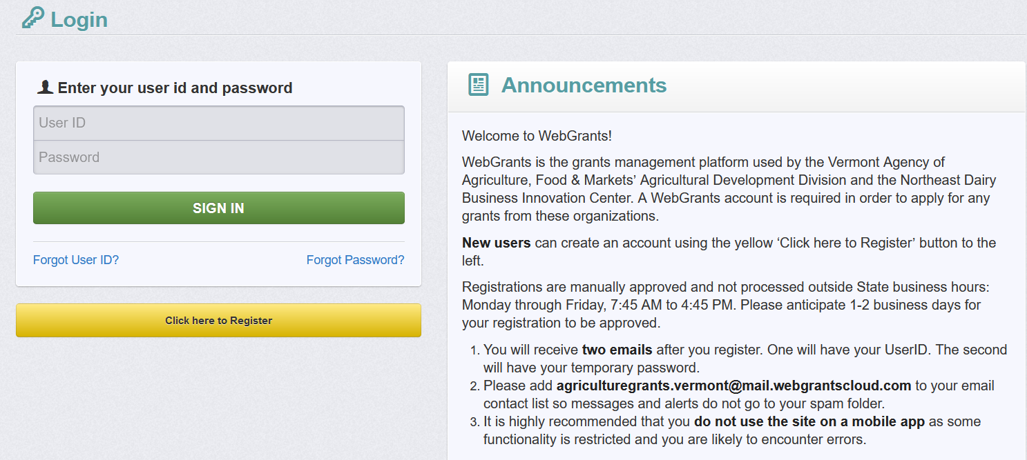

On the Registration page, enter the Personal Contact and Organization Information requested. All required fields are shown with a Red Asterisk *.

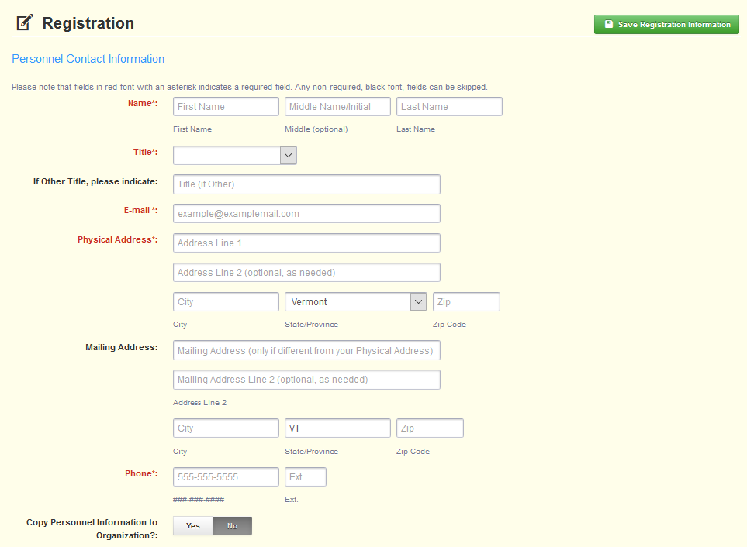

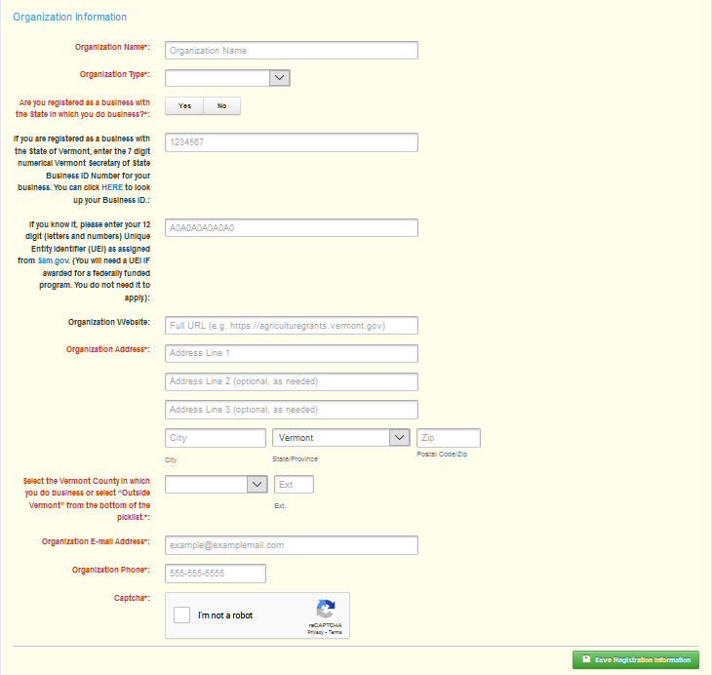

When complete, click Save Registration Information at the top or bottom of the page.

You will receive confirmation of your registration with the message that an alert notification has been sent to your email address.
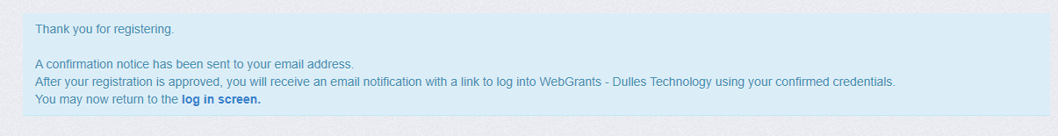

You will receive an email alert similar to the alert below.

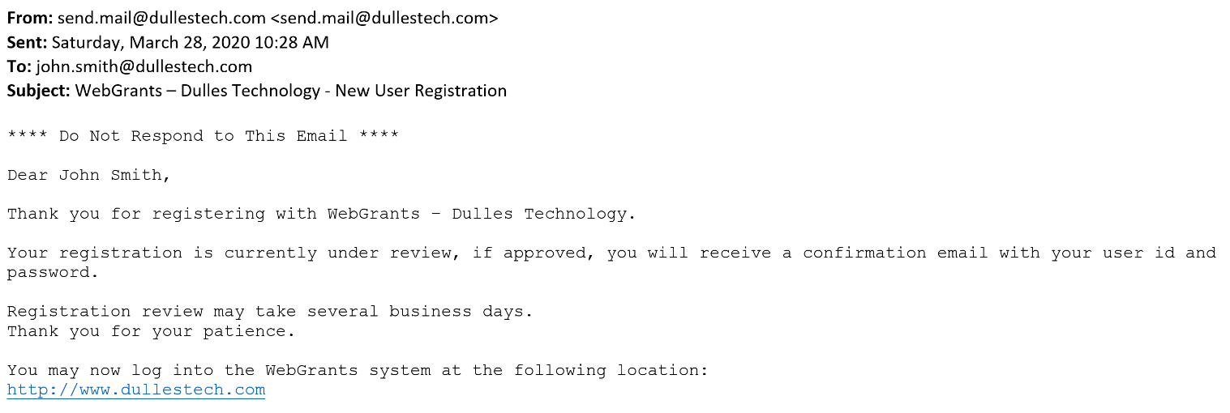

After your registration is approved, you will receive two separate email notifications with your assigned User ID and temporary password, similar to the alerts below. Each email provides the URL for logging into WebGrants.

Email with assigned User ID

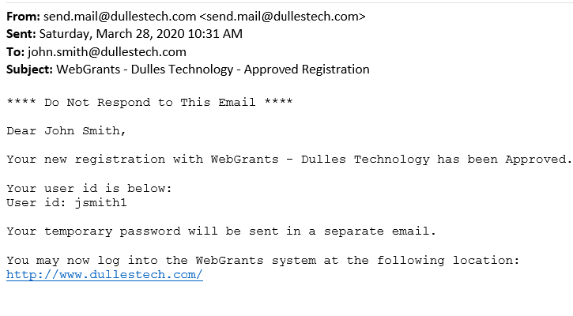

Email with temporary password

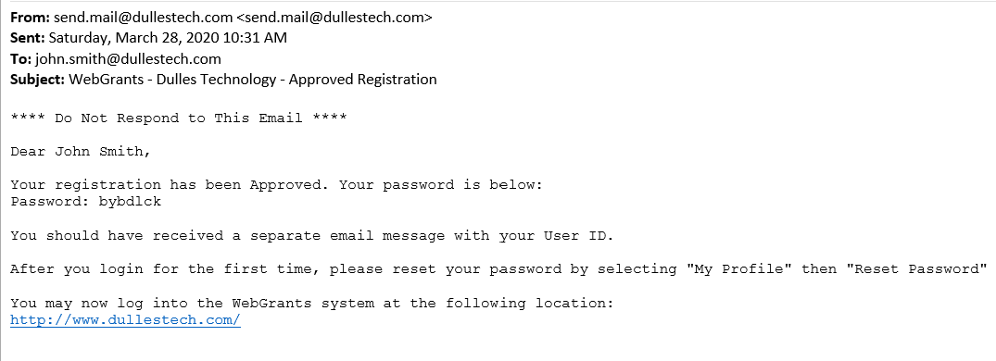

Once both emails are received, you may log into the WebGrants system.

