Welcome to the Agency of Agriculture NEW ONLINE LICENSING page. Below is a list of the Frequently Asked Questions (FAQ) and a guide on how to renew online using your VTPlants ID and PIN number
IMPORTANT: Online renewals open 45 days before your renewal expiration date.

- Frequently Asked Questions (FAQ)
- How to renew/register online

Contents
- Why should I register?
- What information do I need to register?
- How will I get a renewal?
- Where do I find my VtPlants ID and PIN?
- I can’t remember if I registered previously or not, what should I do?
- What do I do if I forgot my password?
- HOW TO REGISTER
- How do I renew my license online?
- Why does my shopping cart say, “You have no items that require payments”?
- Will I need to submit a label/SDS when registering a product for the first time?
- Will I need to submit a label/SDS when renewing products?
- When do you charge a late fee?
- Which programs allow online registration?

(Back to Top)

Why should I register?
Once you register you can manage your license(s), renew them online, print your own license(s), review payment history and update contact information. Online licensing is a fast and easy way of renewing licenses as it saves time and money for our customers.
This is the list of programs allowing online registration currently.

Apiary | Commercial Applicator | Dealer Repairman
Feed Products | Fertilizer Products | Ginseng
Government Applicator | Lime Products | Maple Dealer/Processor
Non-Commercial Applicator | Nursery Dealer | Pesticide Company
Pesticide Dealer A | Pesticide Dealer B | Pesticide Products
Private Applicator | Public Weighmaster | Retail
Seed Dealers | Weights & Measures

(Back to Top)

What information do I need to register for online licensing?
In order to register, you will need your VTPlants ID and your PIN. You also need a valid email address.

(Back to Top)
How will I get a renewal?
This will not change. We will mail you a renewal form 45 days before your license or registration expires if you have not registered online already after we email your renewal to an active email address for your account.

(Back to Top)

Where do I find my VtPlants Id and PIN?
Your VtPlants ID and PIN are printed on your renewal form. If you do not have your renewal form, please contact the Agency at 802-828-2436 or via email: agr.licensing@vermont.gov to obtain your VtPlants ID and/or PIN. Please see the example highlighted below:
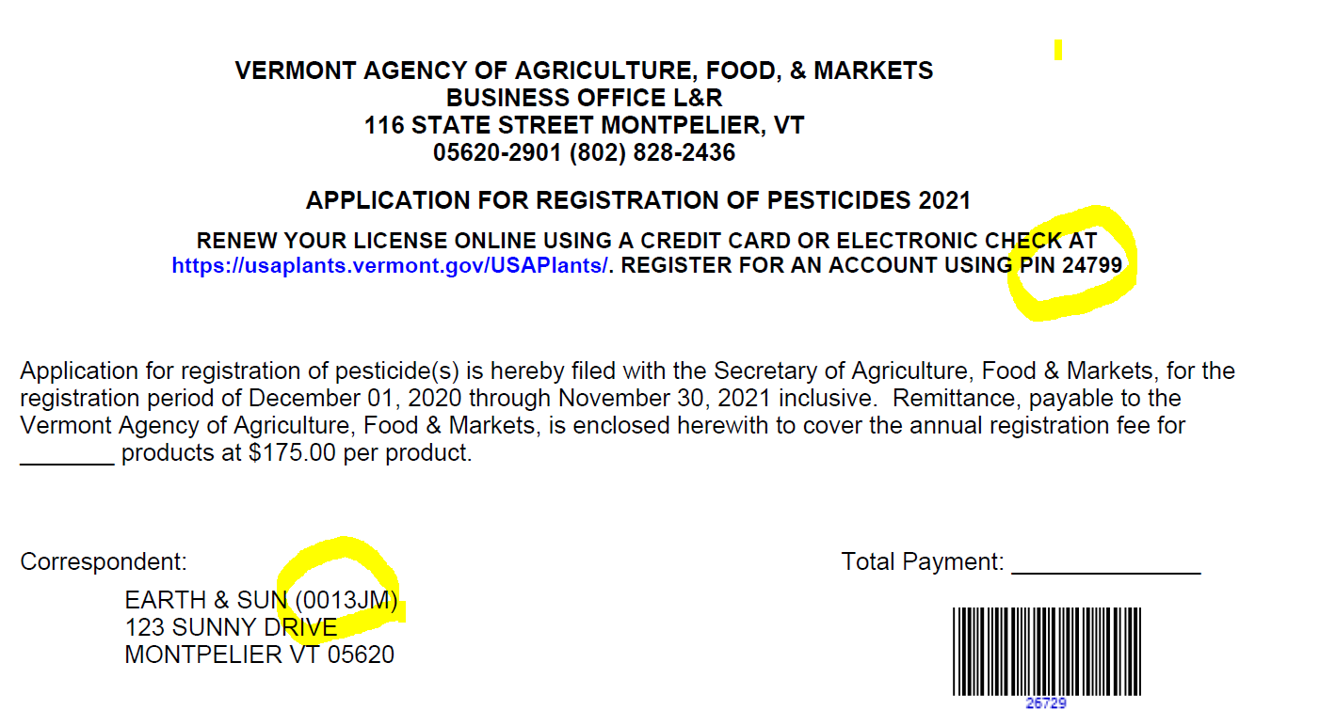

(Back to Top)

I can't remember if I registered previously or not. What should I do?
Try registering again. If you were previously registered, the system will notify you, and send you an email with your username and password.

(Back to Top)

How do I renew my license(s) online?
If you have previously registered with our Agency, please logon to VtPlants using your username and password. If you are registering for the first time, please go to Other Options and use the Register button, please follow the instructions on How To Register.

FYI: Maximum payment allowed for a credit card is $1,000. If paying with ACH, the user will see the name: ‘VT Govt Services’ on their bank statement.
The originator id for ACH for the payment service for USAPlants is 1522077581. If your business is not in the U.S., we do not accept ACH payments, please send us a check

(Back to Top)

What do I do if I forgot my password?
Click on the "Forgot Password" link, and supply either your VtPlants ID or username. The system will email you your password. If your email address has changed, please contact the department at 802-828-2436 or via agr.licensing@vermont.gov
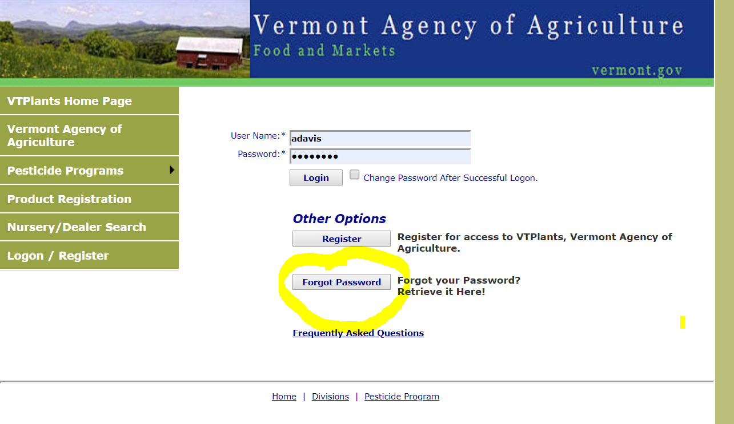

(Back to Top)
HOW TO REGISTER:
- First go to the Login Page.
- Click on the Register button in the middle of the screen.
- Enter your USAPlants ID #.
- Enter the PIN # you were provided.
- Create a username, something unique and easy for you to remember. There are no requirements for special characters such as an asterisk.
- Enter a valid email address. You will need access to this email address for notifications about your license or if you need to reset your password in the future.
- Enter your first name.
- Enter your last name.
- Enter your phone number.
- Create a password. There are no requirements for special characters. We recommend that your password is something you can remember. Take note of the username and password you created; you will need them to login.
- If you forget to fill something in, a red error message will tell you exactly what needs to be corrected before you can save the form.
- Next, save the form by clicking the SAVE button. An email will be sent to the email address provided.

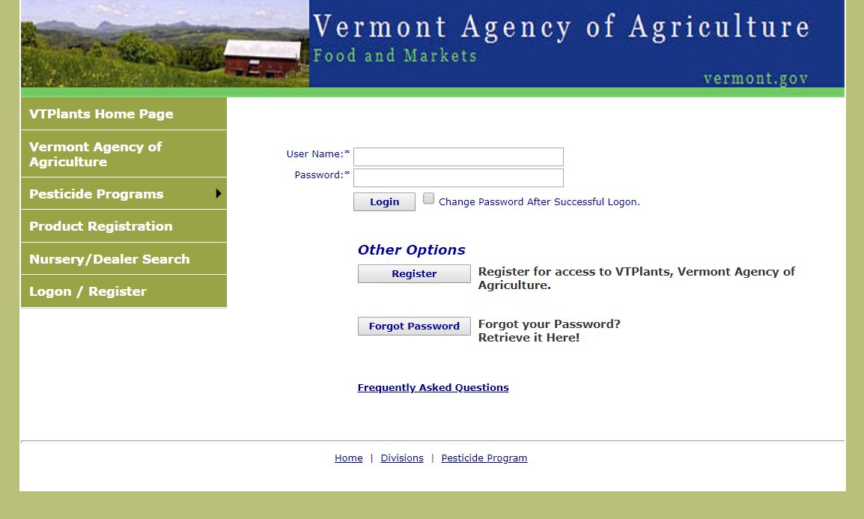

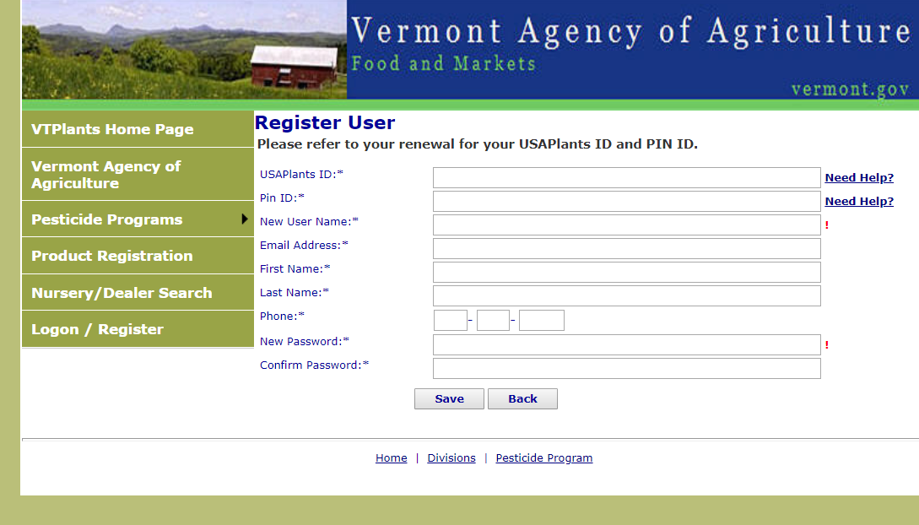

Once you have registered, click on the "Shopping Cart" menu. All licenses that are available for renewal will appear. Check the license(s) you wish to renew and click "Next".
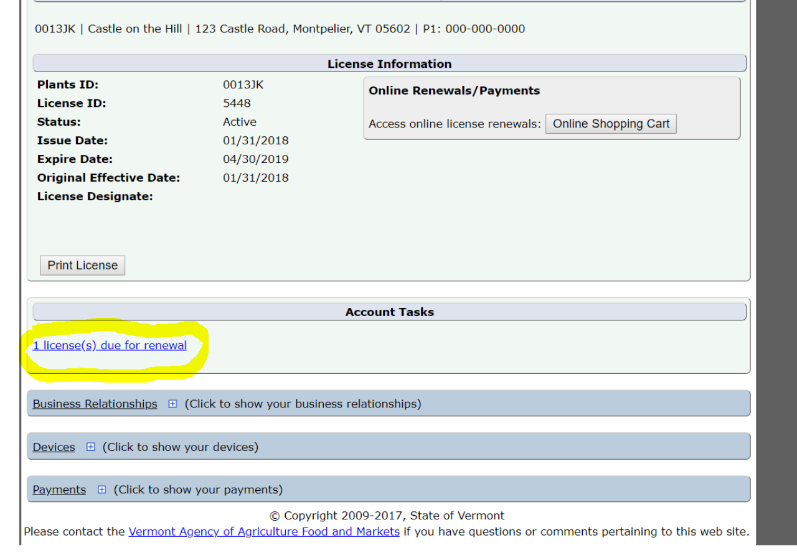

For some programs there is an option for multiyear renewals. If the option is available, it will appear in the dropdown menu under SELECT. Please click on the arrow under SELECT to pick an option. You may use the SELECT ALL ON PAGE option to renew your categories or select them manually using the checkboxes. Then, click ADD SELECTED ITEMS TO CART.

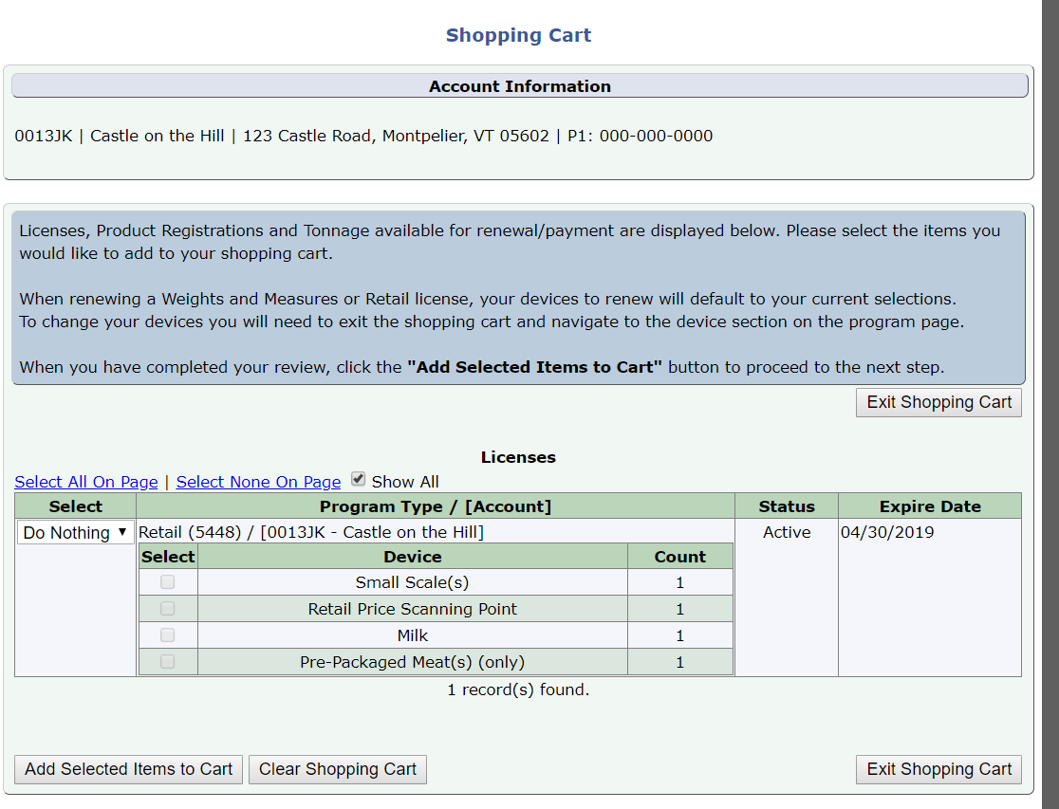

Verify the license information by clicking on the "Verification Needed" link.

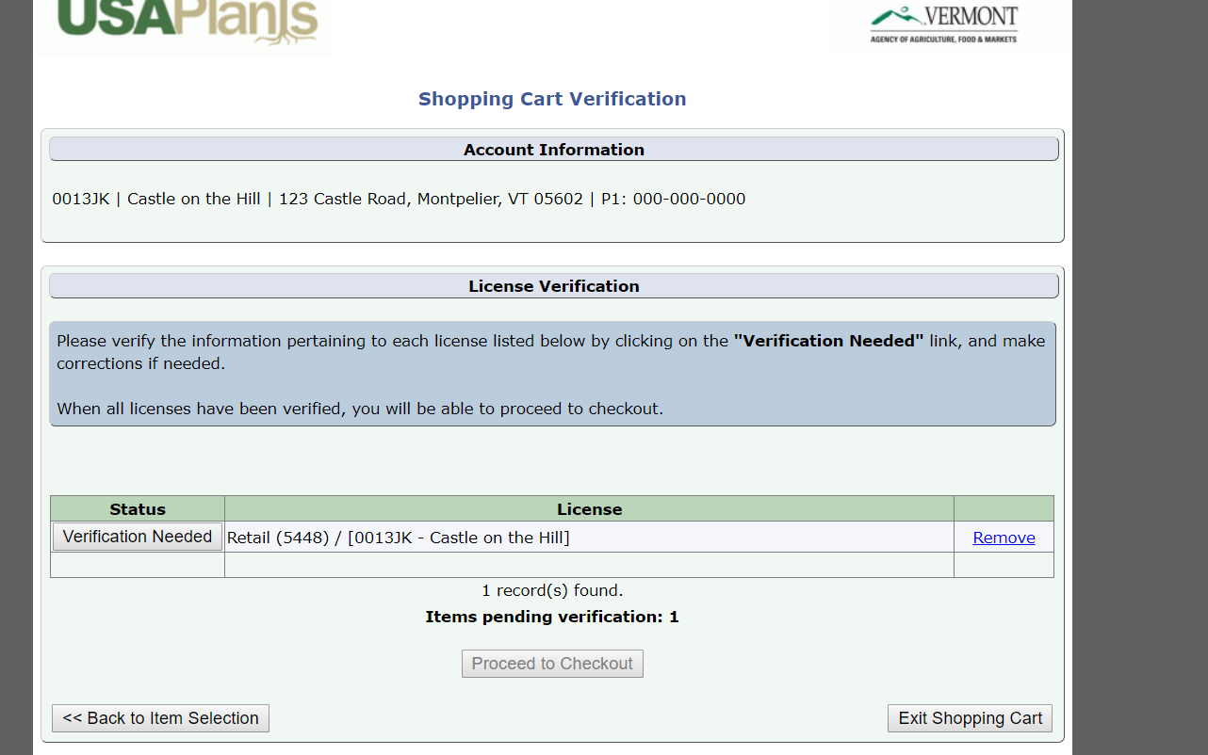

If any changes need to be made to the mailing address, phone number or email, you may do so here. If everything is correct, click “Accept and Continue” to supply your payment information.

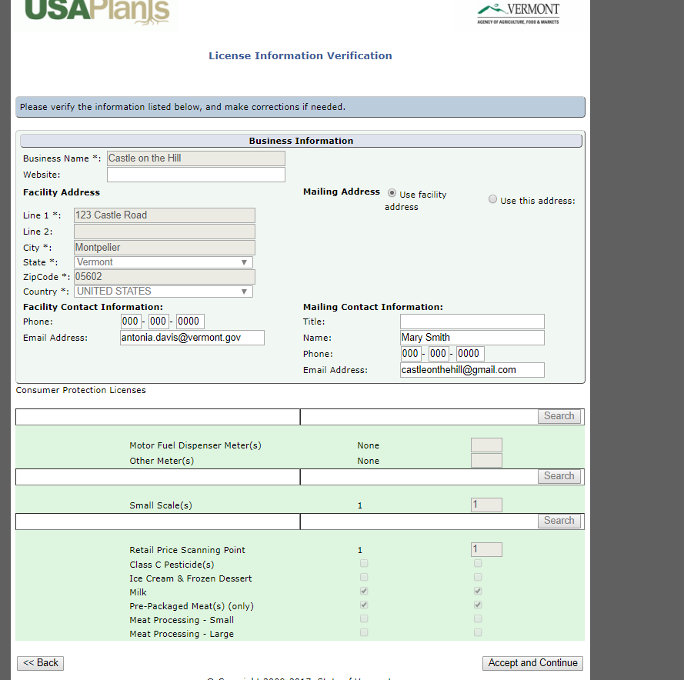

You will now be taken to the “Proceed to Checkout” payment information:

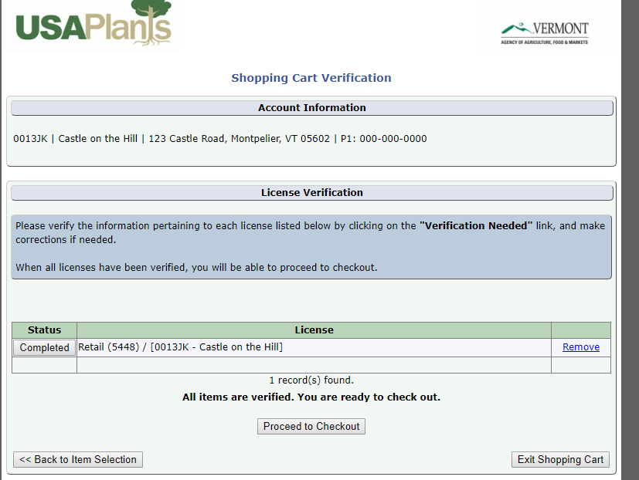

Please read all statements under the Certification carefully. If in agreement, click all checkboxes in order to complete your registration (scroll down to each of them, and be aware that they may be different depending on your license). All boxes must be checked before proceeding to the payment page.

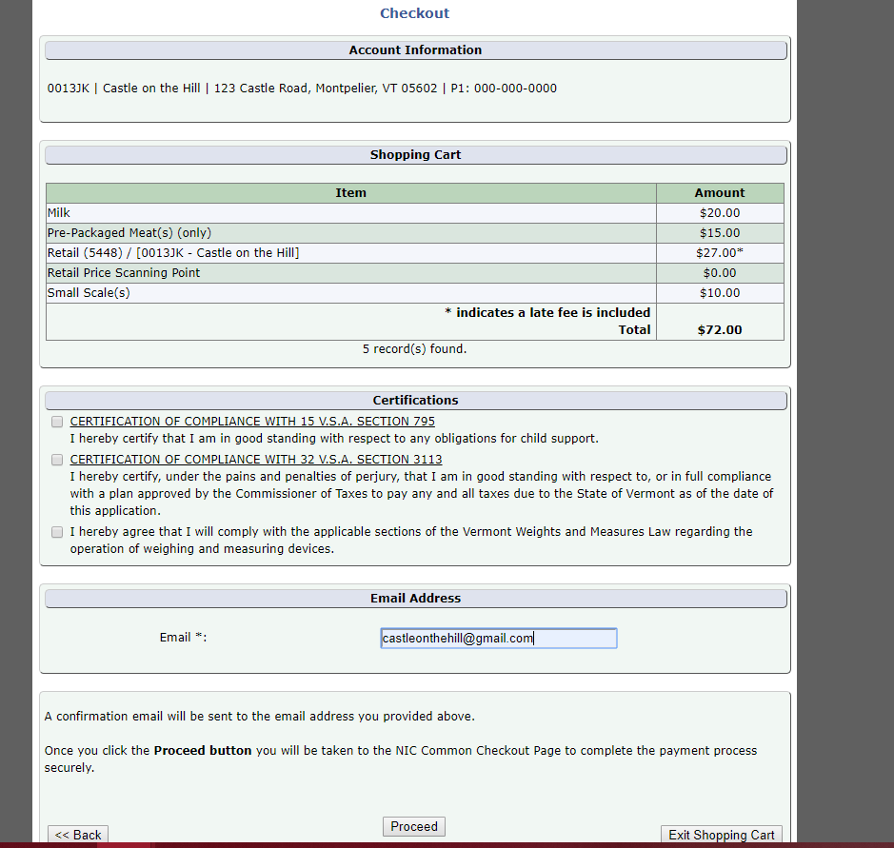

You can now proceed to the supply payment page, which will give you the option to make a payment with either a credit card or e-check.

Please follow the instructions on this page. You will receive an email with your payment confirmation and notification if a late fee was included. You will see the transaction summary on your right, as in the example below:

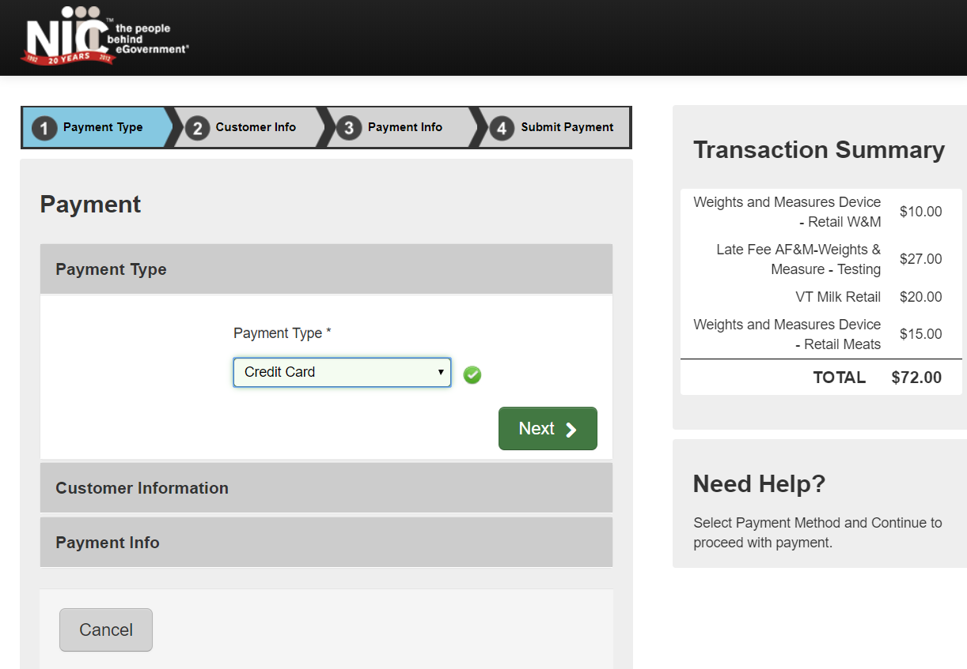

(Back to Top)

Why does my shopping cart say, "You have no items that require payments"?
This could be caused by several reasons:
- You have already renewed your license(s)
- Your account is setup as a "secondary" account to a "primary" account. The "primary" account (usually corporate or headquarters) is the only one that can renew licenses for secondary accounts. If you see a "Business Relationships" grid on your program page, then your account could be a secondary account, i.e. see below:
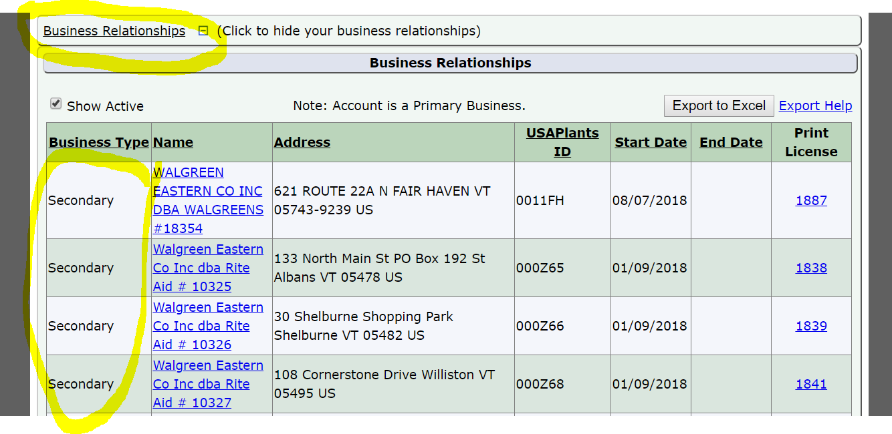
- If your license requires continuing education credits, you may not have enough credits.
If you believe you should be able to renew a license, but do not see it listed, you can contact the department at 802-828-2436 or email agr.licensing@vermont.gov

(Back to Top)
Will I need to submit a product label and/or SDS when registering a product for the first time?
Yes, new Pesticide products will need a label and an SDS to be uploaded into VtPlants in order to be reviewed for approval when registering online. The system will indicate when/where you need to upload your paperwork. If using third party agent, registrants may upload labels to ALSTAR.
Feed, Fertilizer and Lime products will need a label uploaded to the system as well.

(Back to Top)
Will I need to submit a label/SDS when renewing products?
Yes, if your product label is not in the system already or you have made changes to your label, you will have to upload it. If using third party agent, registrants may upload labels to ALSTAR.

(Back to Top)

When do you charge a late fee?
Renewal licenses not received by the Agency 30 days past their expiration date are required to pay a late fee of $27.00. If this is the case, please include the late fee with your renewal payment.

Products registration will pay $27.00 per renewal package, not per product.

Retail, Weights & Measures, and Apiary will pay $27.00 or 100% of the renewal fee, whichever is less; for instance, if you are licensed only for Prepackaged Meats which is $15.00, your late fee will be $15.00 not $27.00.

(Back to Top)

