Submitting a Status Report in WebGrants

Logging into the WebGrants System

Sign into Web Grants

Url: Enter Current URL here

On the Login Page

Click on User ID on the left side of your page under Login

Enter your User ID

Enter your Password

Click on ‘Sign In’

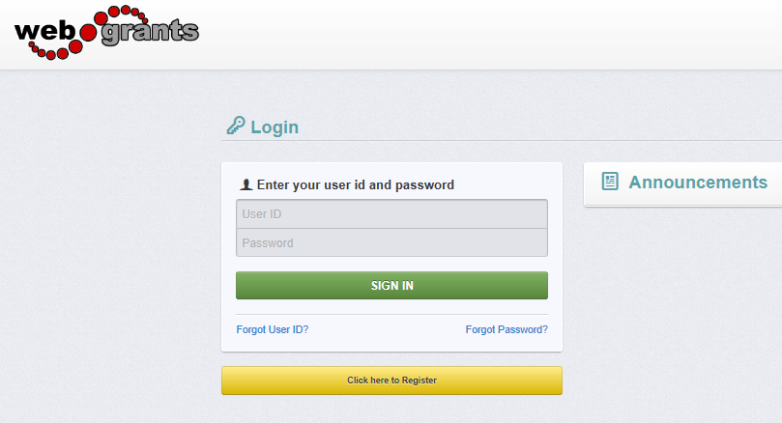

Note: Use the WebGrants Menu, not the Browser Menu

WebGrants is compatible with many different browsers; please feel free to use the browser of your choice.

Read the Instructions on the screen for navigating in the system.

From the Side Menu:

Click on ‘Grants’:
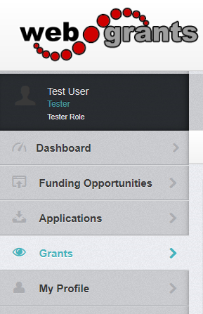

Select the Grant you would like to access in the Active Grant listing.

If you need to access a closed grant, click on the Closed Grants tab.

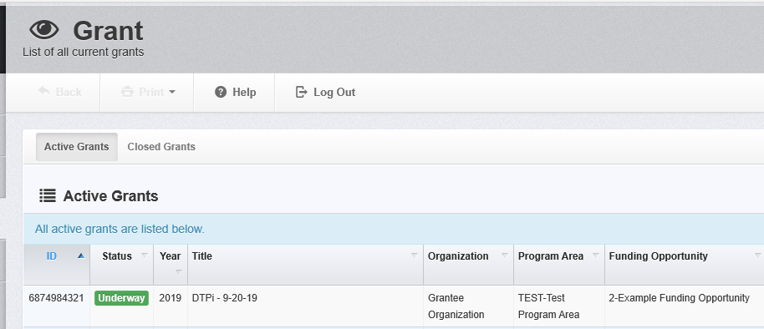

Once you have selected the Grant, you will be directed to the Grant Components.

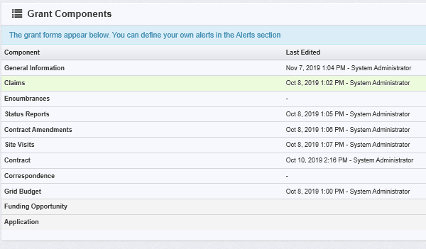

Select 'Status Reports' from the list of Grant Components

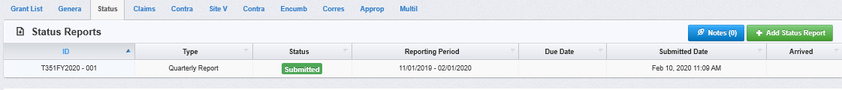

Click on 'Add Status Report'.
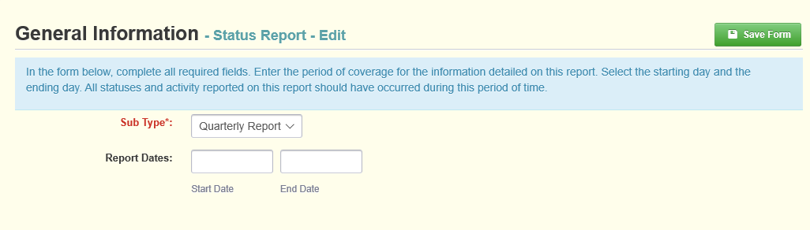

Choose the 'Sub Type'.

Enter 'Report Dates'. Start Date and End Date.

When complete, click 'Save Form'.

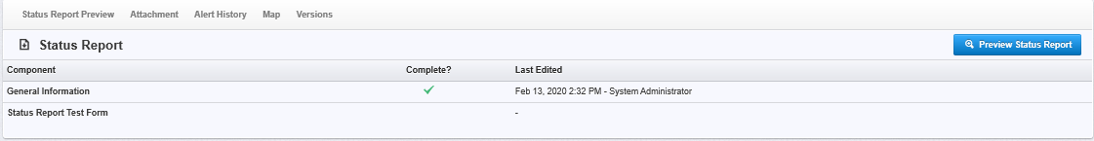
Click on the status report form(s) listed under Components.

(Status Report Test Form in this example)

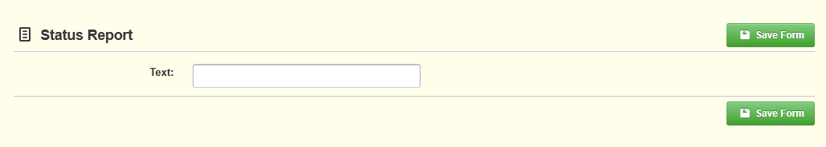

Enter the requested data and click on 'Save Form'.

Review form and if correct, click on 'Mark as Complete'.
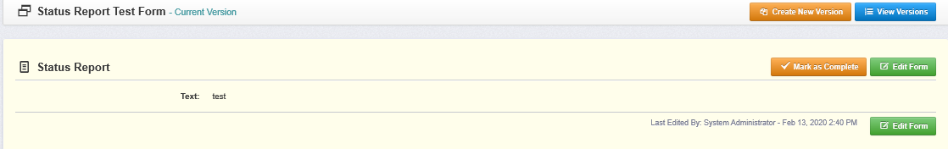

If status report is ready for submission, click on 'Submit Status Report'.

