WebGrants Instructions for Applying for Funding

Logging into the WebGrants System

Enter the URL for WebGrants: https://wg7test.webgrantscloud.com

On the Login Page

Click on User ID on the left side of your page under Login

Enter your User ID

Enter your Password

Click on ‘Sign In’

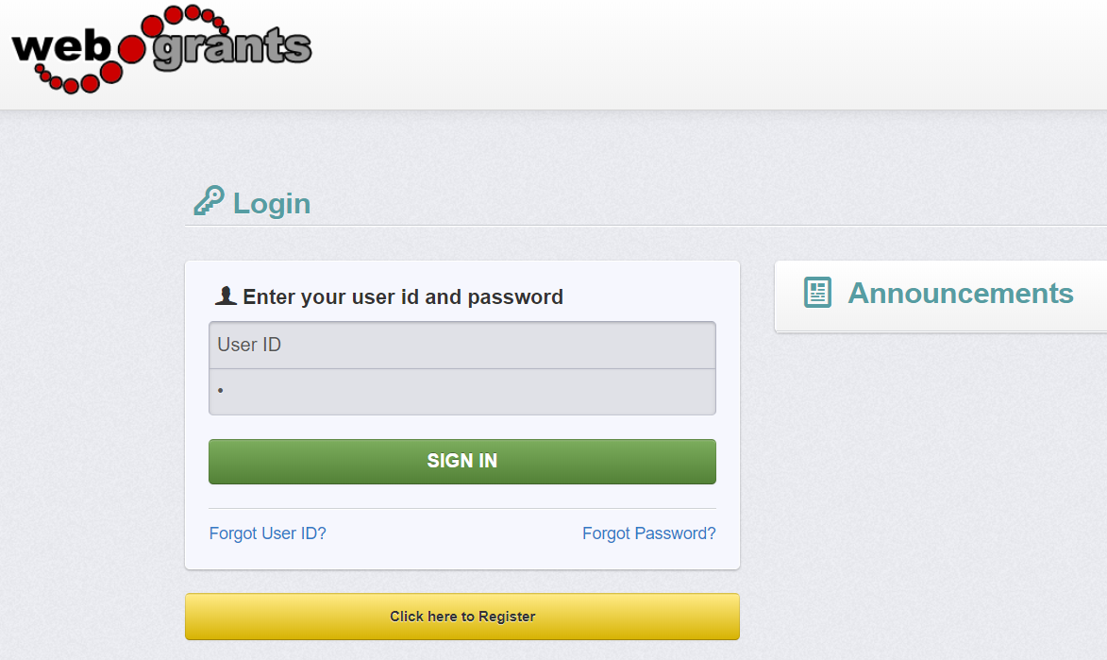

Notes before you Start your Application: Use the WebGrants Menu, not the Browser Menu.

WebGrants is compatible with many different browsers; please feel free to use the

browser of your choice.

Read the instructions on the screen for navigating in the system.

Creating an Application

From the Side Menu:

Click on ‘Funding Opportunities’:

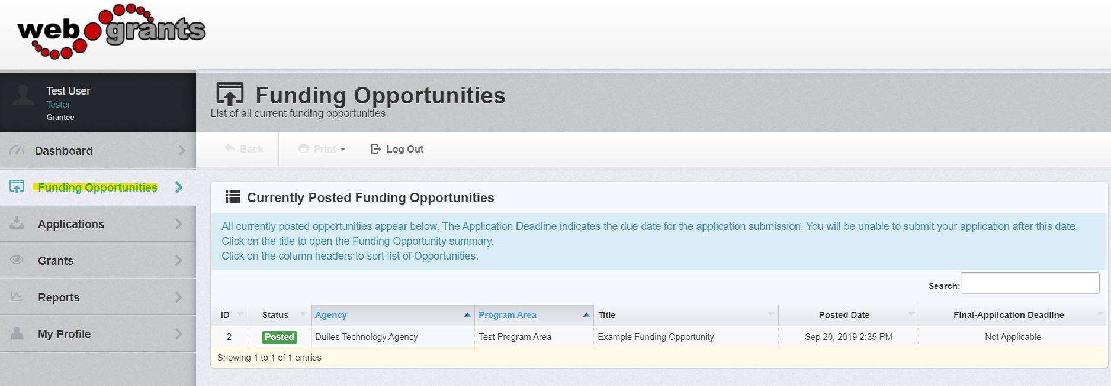

Select the ‘Opportunity Title’ you are applying for.

Read the Funding Opportunity description to ensure eligibility requirements.

Click on ‘Start A New Application’:

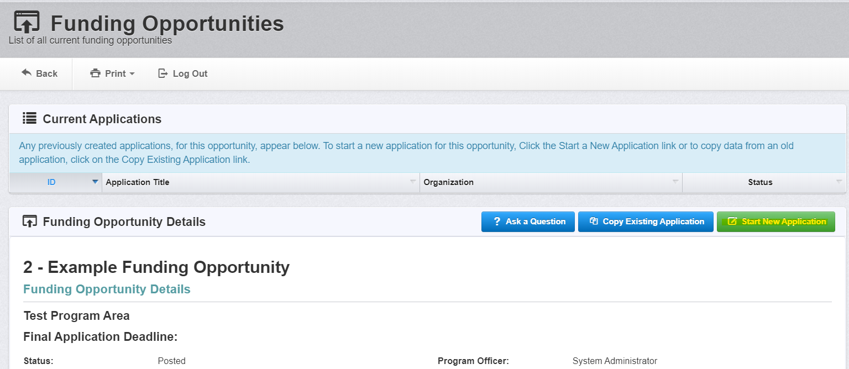

Note: At any time you may click on ‘Ask a Question’ and submit a question into the system. When the Program Officer answers your response, you will receive an email alert from the WebGrants system

General Information Page

This is a system page that pulls from the People and Organization database. The system identifies the User and the association with their Organization. This is identified when a user registers for access to WebGrants.

Complete Step 1 in the Application Creation Wizard, then click ‘Save Form Information’:

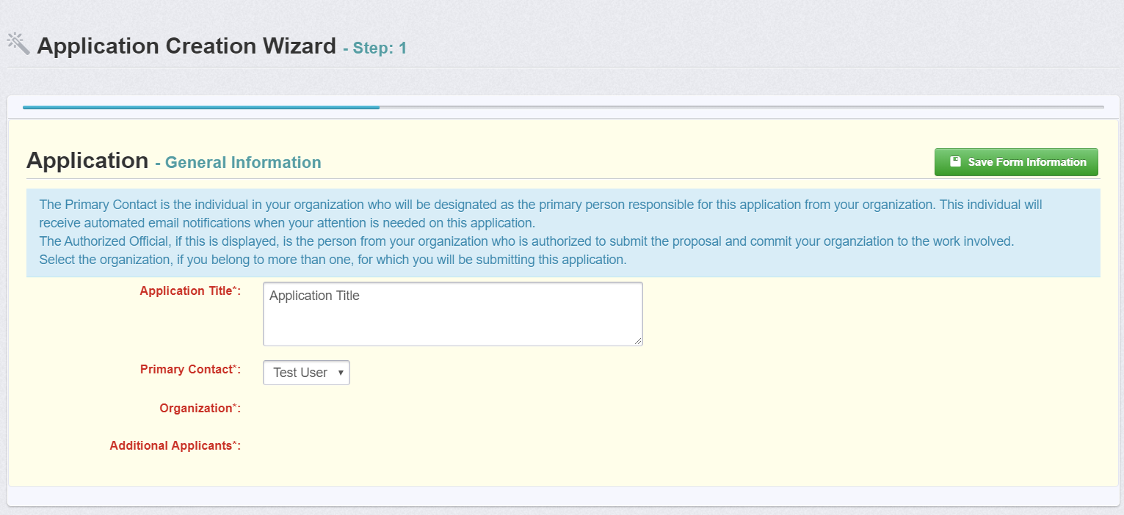

Choose your Organization from the drop-down in Step 2 of the Application Creation Wizard. Then click ‘Save Form Information’:

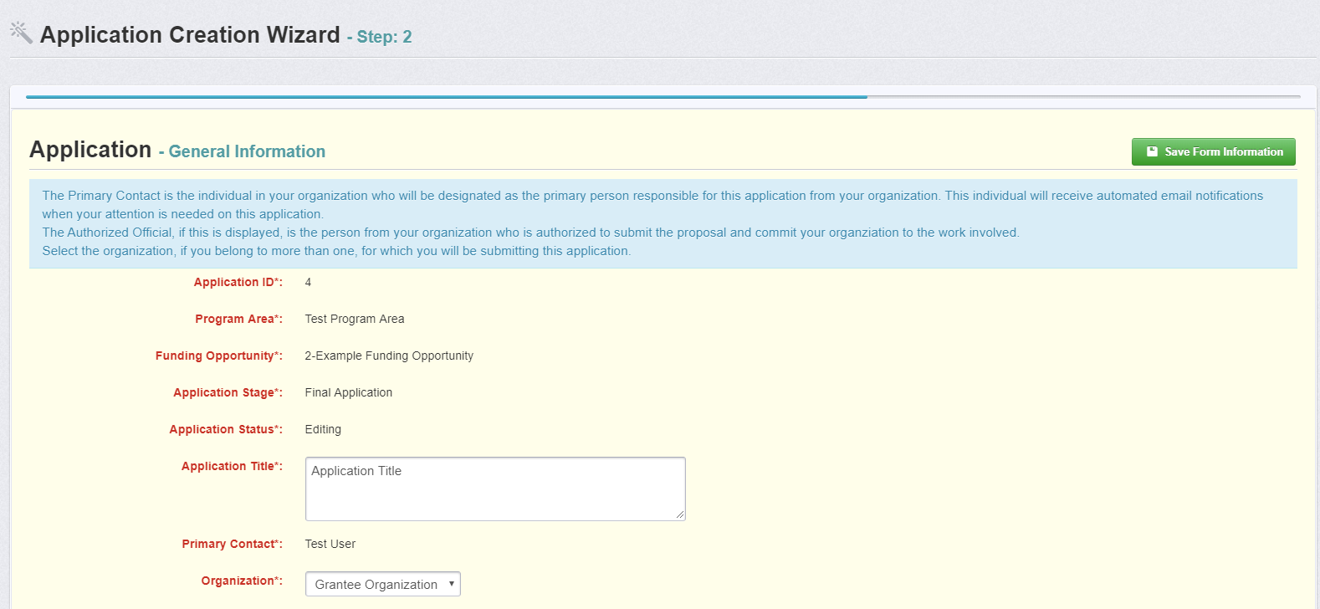

If you would like to add any ‘Additional Applicants’ from your Organization, you can add them in Step 3 of the Application Creation Wizard. Then click ‘Save Form Information’:

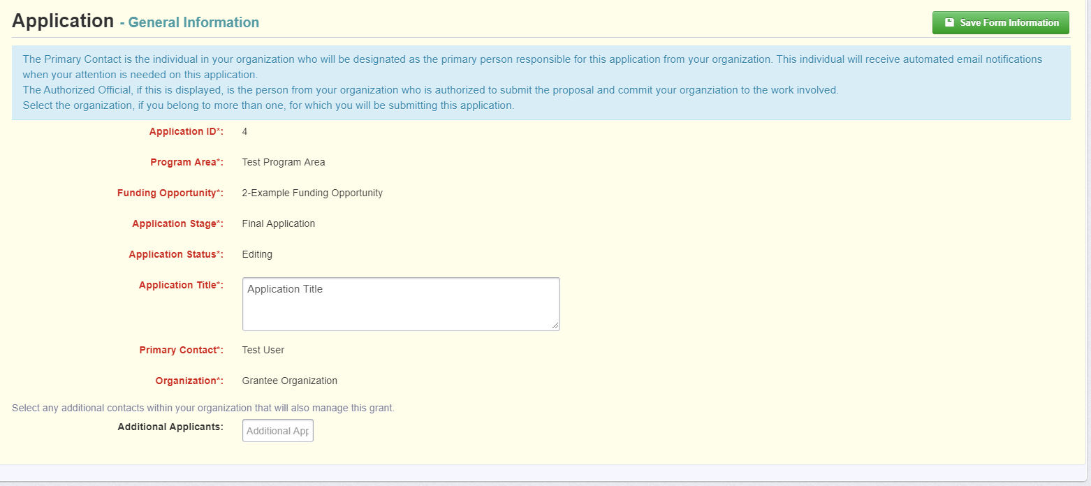

Note: The system has created and assigned the application # when you clicked ‘Save’. If you log out of the system at this point or any future point: DO NOT CLICK ON START A NEW APPLICATION.

You can click on ‘Applications’ from the Side Menu or;

Click on ‘Funding Opportunities’ and you will see your application in the top section.

Completing an Application

Once you have completed the General Information, you will be returned to the Application Details:

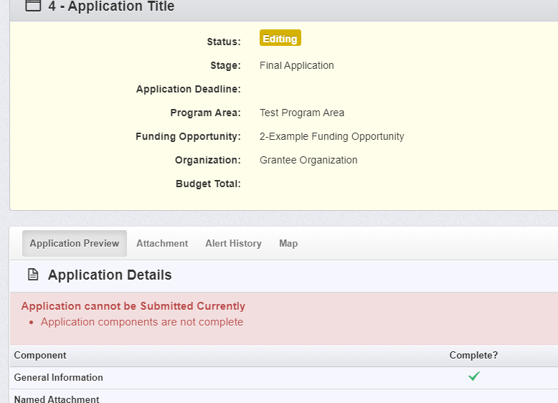

Note: The Applications Details page will show a header in pink letting you know that

you are required to mark all the forms complete or the application cannot be submitted.

The system will show a complete listing of all application forms that are to be completed by the applicant to apply for funding in the WebGrants System. Click on the next form listed underneath the General Information which you just completed.

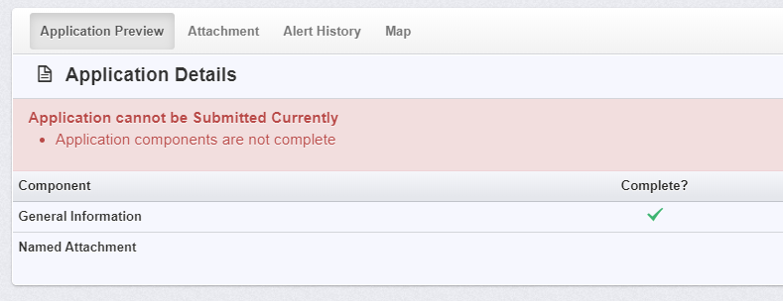

You will continue to click on each form in the Application Details listing.

Navigating in the WebGrants System

Most forms are editable by clicking ‘Edit’ at the top part of the section of the form. However, multi-list sections are editable by clicking ‘Add’ on the section. If you are completing a multi-list section, you can create as many rows necessary to complete the section. If you want to delete a row, you will click on the row and click ‘Delete’.

All information must be saved by clicking ‘Save’ on the forms. If you do not click ‘save’ and you back out of the form or section of the form, your information will be lost.

Reminder: If you log out of the system at this point or any future point: DO NOT CLICK ON START A NEW APPLICATION.

You can click on ‘Applications’ from the Side Menu or;

Click on ‘Funding Opportunities’ and you will see your application in the top section.

Once you have completed the entire application and marked all forms complete, your application is ready to submit. You will notice that your header has turned green.

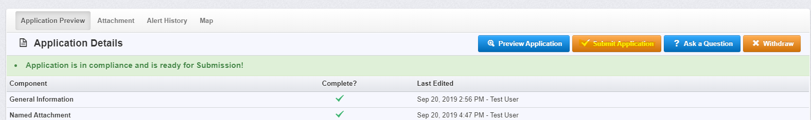

Submitting the Completed Application

Click the ‘Submit Application’ button.

You will receive a pop-up confirmation informing you that once you click ‘Submit’ the system will no longer let you edit the application.

If ready, click ‘Submit’.

The system will take you back to your Current Applications listing and will show you your submitted application.

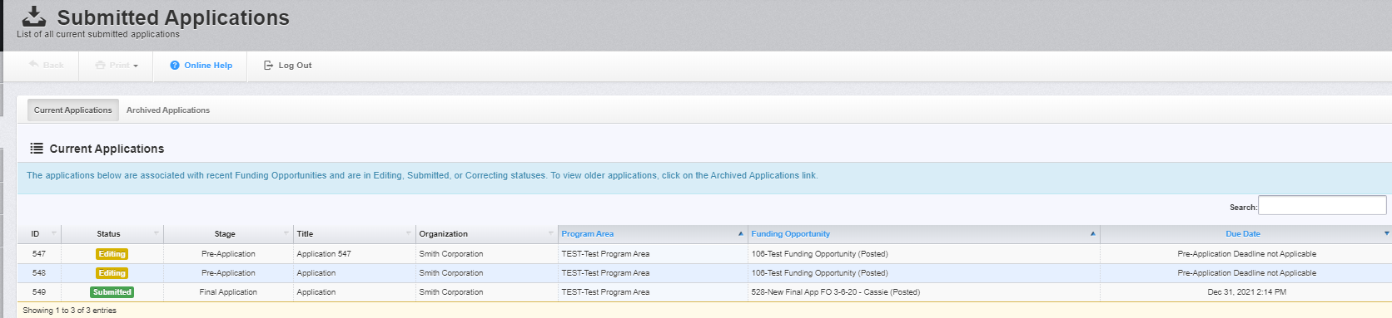

Printing the Submitted Application

Click on your application in ‘Submitted’ status.

Click ‘Print’ on your top menu and select ‘Send to Printer’

When finished, click on ‘Log Out’.

