Sponsorship Request Form | 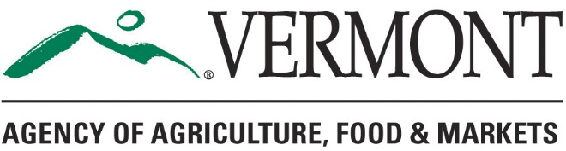

Contact Information
Organization Name
Contact Name
Street Address
City ST Zip Code
Contact Phone Number
E-Mail Address
Event Name
Event Date
VAAFM Sponsorship Dollars Requested

Sector Criteria
Which of the following does your event/conference address? A minimum of three are required.
☐ Agricultural/food systems workforce development
☐ Increase food access to a specific population
☐ Increase agricultural business or value-added product development capacity
☐ Build consumer awareness around local food
☐ Promote agricultural practices and stewardship of natural resources, and farmland stewardship and farmland access
☐ Agricultural education and agricultural literacy

Event History with the Agency

Has VAAFM funded this event in the past? If so, how much?

Event Description

Brief description of how event furthers the Agency’s mission to promote sustainable and equitable food systems, agriculture workforce development, innovation in agricultural product development, or land access and stewardship.

How many years has the event been held?
What is the estimated number of vendors/presenters?

What is the estimated number of attendees?
Who is the target audience for this event?

Projected Impacts
Is this a statewide, northeast regional, or international event?
Is this reaching/serving an economically challenged area?
How do you plant to reach a diverse audience in promotion of this event (e.g. geography, socioeconomic, age, race, culture)?
How does this event support ag industry resiliency, diversification, or innovation?
Describe the event’s effect on different ag industries (for example dairy, produce, value added, maple, Vermont made)

Sponsorship Information
Please describe sponsorship benefits to the Agency? (i.e. levels of sponsorship & corresponding benefits, speaking opportunity, publicity – print/radio/social media)
Have other state agencies been approached?

