VERMONT PAYMENT FOR ECOSYSTEM SERVICES & SOIL HEALTH WORKING GROUP
PROGRAM OBJECTIVES, ELEMENTS AND ASSUMPTIONS

Vision:
A Payment for Ecosystem Services and Soil Health Program will promote climate mitigation, provide clean water, and support the broader ecosystem for all Vermonters while supporting the economic health of Vermonters engaged in agriculture.

Goals:

The PES Program will:

- Compensate farmers for providing clearly defined ecosystem services
- Ensure that metrics and associated compensation are clearly and directly linked to the specific, quantifiable ecosystems services of carbon storage, nutrient, soil and stormwater retention, and ability to support biodiversity
- Identify and pay for ecosystem services that could be provided by farms of diverse types and sizes, including those currently and historically underserved
- Be efficient with time and funding to ensure that a high return is provided to the farmer and society
- Continually improve both research and the program to support agricultural innovation, adaptative management and development of new practices and tools

Framework:

Eligibility
- All farmers are eligible to participate in the program if they are in good standing with the Required Agricultural Practices (RAPs)
- Disadvantaged farmers have additional technical assistance to participate
- Farmers are paid a base fee to participate, at least in the first year(s), which in turn will require certain paperwork, data gathering and soil sampling
Program Phasing
- The program will be phased in to allow for implementation in 2023 but able to grow in the services it pays for over time
- The program will start as a one-year pilot/demonstration at the scale funding allows to move action forward soon, learn, and get payments into farmers’ hands for producing ecosystem services.
- The pilot will need to set eligibility for the pilot guided by the objectives stated above.
- The pilot will seek to be representative of the outcomes it seeks to achieve and the diversity of farms it intends to reach.
- The pilot program will be administered by the AAFM because of its authorities, expertise staffing and ability to get going sooner but the ultimate program administrator will be determined during the pilot.
- The PES WG will stay engaged throughout to support, monitor, and provide guidance of the pilot program including making final recommendations for a full-fledged program and its administration based on the pilot/demonstration and its lessons
Program Elements
- The program will pay for ecosystem services based on outcomes, which may be determined via real-time measurements, modeling, and intermediary tools, and/or other methods
- The program will use tiering that could involve: 1) enrollment and basic data collection and soil testing; 2) payments for widely supported evidence-based practices that produce ecosystem services; 3) payments for soil health and other measured outcomes with more extensive monitoring and sampling; 4) potential research or innovation tier (i.e., California program approach).
- The program will incorporate a research element to: 1) monitor and provide analysis for program development and adaptive management; and 2) support innovation and development of new practices and tools over time
- The program will track results and make improvements to the program on a periodic basis for continuous improvement
- The program will integrate farmer learning networks and other collaborative tools for co-production of benefits and improvements to the program overall over time.
- To the greatest extent possible, the program will seek to use existing tools, data interoperability, and tools from existing programs for efficiency and ease of use.
- The program will coordinate with, be additive to, and be compatible with existing funding programs to the greatest extent possible
- The program will seek to support biodiversity within farming practices and actions that maintain farmland in production.
- The program will ensure that ecosystem services are valued such that farmers’ marginal benefit from enrolling meets their marginal cost, and that adequate technical assistance is provided to assist farmers to enroll.
- The pilot will identify ways to deploy technical assistance in an effective and efficient manner, in part, by using existing talent on the ground through such means as the conservation districts, extension, and the farmer watershed groups.

Program Tools
- A Vermont-tailored Cornell Comprehensive Assessment of Soil Health (CASH) test will be developed during Year One but a standard or modified CASH test will be used in Year One as the Vermont-tailored version is developed.
- Exact models to be used are to be determined but could include RSET, APEX, others, or some combination. Farmer-led tools (like observation and in-field tests) will also be incorporated wherever possible.
- Whatever models are used, they should be tailored to Vermont.

Payments
- Payments will be based on evidence-derived values that consider both society’s willingness to pay (WTP) and farmer’s willingness to accept (WTA)
- The program and the pilot will seek to maximize funding from a variety of sources to the extent possible (state, federal/NRCS, and other sources).
- The program will pay for: 1) practices that lead to quantifiable outcomes; 2) outcomes that are produced through various practices; 3) some combination of the two.
- Payments are for: 1) measured improvements from their farm’s baseline (field, soil type, cropping type, etc.); 2) having a soil health or other kinds of score that is equal to or greater than a stated threshold (field, soil type, cropping type, etc.); 3) some combination (TBD); 4) how to account for payments for biodiversity and other potential non-soil health metrics?
Public and Farmer Engagement
- The program will partner with existing agencies and initiatives across the state to increase public understanding and appreciation of the critical role of agriculture in healthy landscapes and how ecosystem services benefit quality of life in the state.

Pilot Development Process
- WG will develop program parameters and elements by 31 May 2022, based on the UVM work to date, case studies, suggested program designs offered to date to the WG, and discussions and dialogue among the WG.
- AAFM plus small design team of PES WG members will work June-August 2022 to develop the program in detail based on the WG’s parameters.
- WG will be kept informed via at least bi-weekly email updates.
- The PES WG may want to engage farmers in the program parameters and elements in early summer 2022, if possible, for comment and feedback.
- The Design Team will report back to the PES WG in September 2022.
- The PES WG will refine and hone final issues and questions with the Design Team.
- The pilot program will then be finalized, and implementation will begin by 31 December 2022.

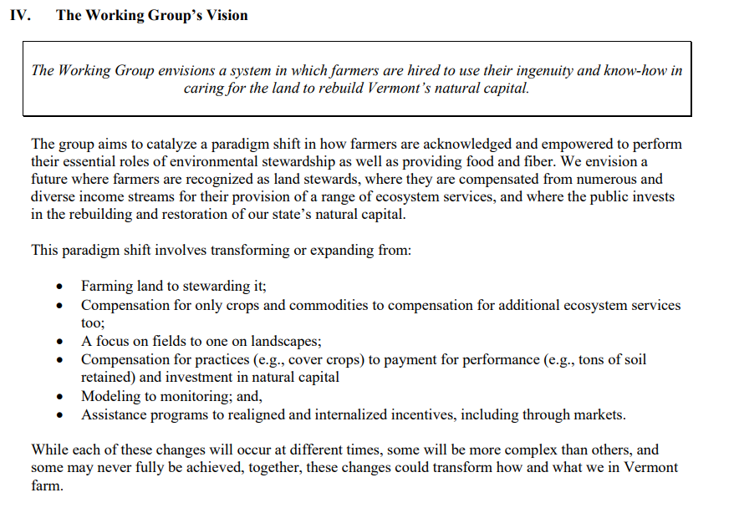

RAP definition? USDA definition? Other? $2,000 sales or 4 or more than acres
USDA definition? Other?
Socially Disadvantaged Farmers and Ranchers (SDFR) could also be given a higher rank in proposal review
Note that data privacy is related to the funder’s requirements not the administrator’s

