May 2021

Table of Contents

Abbreviations and Symbols….……………….……………………………………………………..1
Number of Farms, Farmland, and Field Crops…………….…………………………………...…...2
Vegetables and Melons……..………….……………………………………………………………3
Floriculture and Nursery Crops……………………………………………………………………..4
Fruits and Berries……….….…..……….…………………………………………………………..5
Honey……………………………………………………………………………………………….6
Dairy and Livestock…….……………………….…………………………………….……….…6-7
Special Commodities….…….………………………………………………………….…….......8-9
Economics…………………………………………………………………………………………10
References……………………………….………………………………………………………...11

Abbreviations and Symbols
(NA): Not Available
(D): Withheld to avoid disclosing data for individual farms
(X): Not Applicable
Vermont’s State Flag

Number of Farms and Farmland
By Sales Class: January 1, 2021
Sales Class | Number of Operations | Acres Operated | Average farm size (Acres)
$1,000-$9,999 | 3,750 | 280,000 | 75
$10,000-$99,999 | 1,950 | 310,000 | 159
$100,000-$249,999 | 470 | 140,000 | 298
$250,000-$499,999 | 320 | 130,000 | 406
$500,000-$999,999 | 140 | 80,000 | 571
$1,000,000 or more | 170 | 260,000 | 1,529
Total | 6,800 | 1,200,000 | 3,038

Field Crops
January 1, 2021
Item | Corn for Silage | Alfalfa Hay | Other Hay
Acres Harvested | 80,000 | 275,000 | 230,000
Yield per Acre (tons) | 19 | 3.14 | 2.94
Production (tons) | 1,520,000 | 864,000 | 677,000
Marketing Year Price per Ton | (NA) | $146.72 | $132
Value of Production (million dollars) | (NA) | 126.764 | 89.364

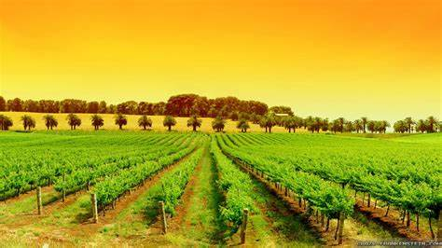

Vegetables and Melons
January 1, 2021
Crop | Yield per Harvested Acre (pounds) | Price per Pound*
Asparagus | 1,200 | $4.10
Beans, Snap | 1,900 | $3.25
Beets | 6,300 | $1.20
Broccoli | 2,600 | $1.90
Cabbage | 14,000 | $0.50
Cantaloupe and Muskmelon | 8,000 | $1.10
Carrots | 11,200 | $1.25
Cauliflower | 4,400 | $1.55
Cucumbers (Excludes Pickles) | 11,600 | $1.00
Eggplant | 4,000 | $3.00
Garlic | 2,900 | $11.00
Kale | 8,500 | $1.40
Lettuce, Head | 10,300 | $1.45
Lettuce, Leaf | 7,400 | $1.75
Lettuce, Romaine | 8,000 | $1.20
Onions, Dry | 6,600 | $1.60
Onions, Green | 8,600 | $2.25
Peas, Green (Fresh Only) | 1,200 | $3.90
Peppers, Bell | 9,000 | $2.05
Peppers, Other | 4,700 | $2.55
Pumpkins | 27,200 | $0.15
Squash, Summer | 16,400 | $1.00
Squash, Winter | 9,000 | $0.85
Spinach | 4,100 | $8.00
Tomatoes | 7,600 | $2.95
Watermelon | 9,400 | (D)
*Average fresh market price at point of first sale.
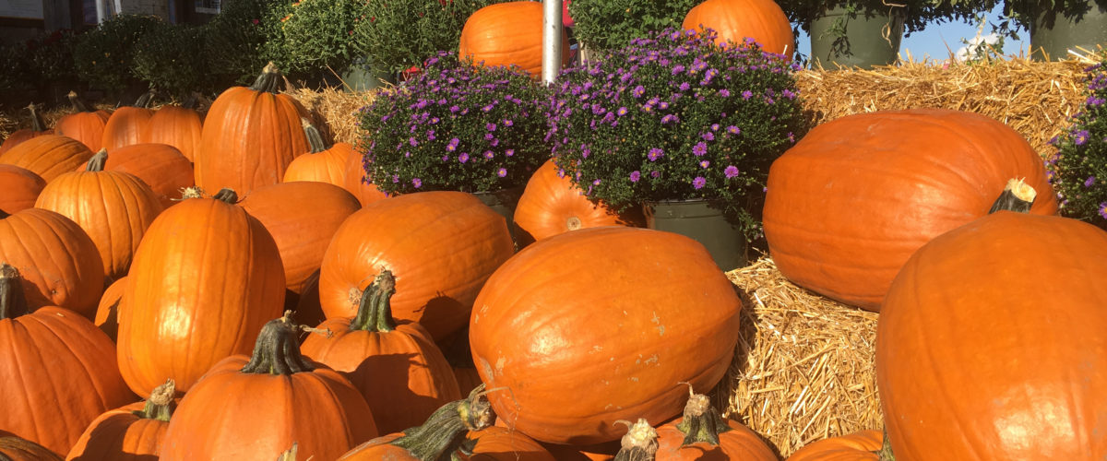

Floriculture and Nursery Crops
January 1, 2020

Item | Number of Farms | Sq. Ft. Under Glass/Other Protection | Acres in the Open | Value of Sales (dollars)
Annual Bedding Plants | 70 | (D) | (D) | 5,972,537
Indoor Foliage Plants | 14 | (D) | (D) | 454,780
Potted Flowering Plants | 20 | (D) | (D) | 1,764,108
Organic Floriculture | 47 | 141,073 | 24 | 1,484,175
Nursery Stock Crops | 35 | (D) | 1,283 | 2,053,598

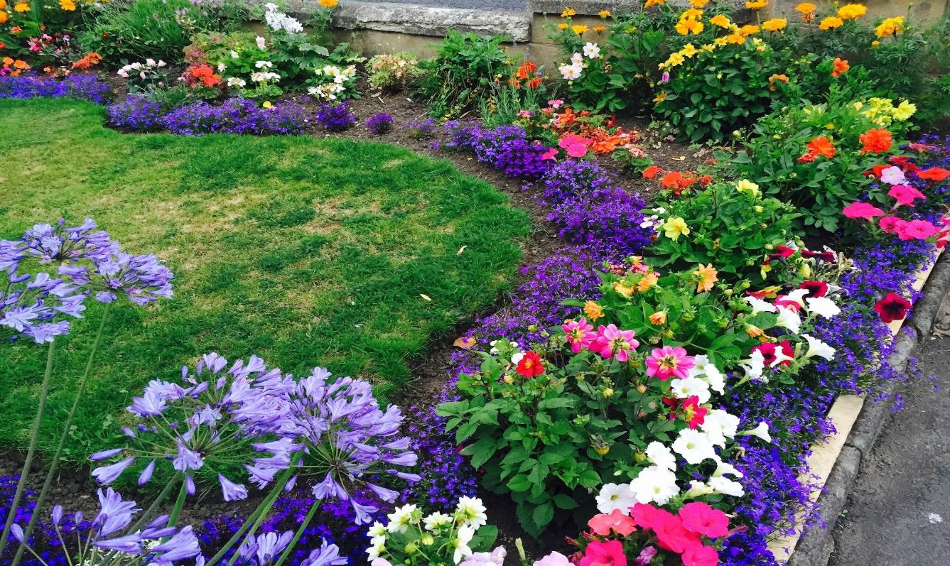

Did You Know?
Vermont was able to produce over $10 million in sales from
floriculture and nursery crop in 2019.

Did You Know?
Greenhouse and nursery product
sales totaled over $10 million in
2019.

Fruits and Berries
January 1, 2021
Crop | Yield per Harvested Acre | Price*
Apples | 257 bushels | $33.20/bushel
Blueberries, Cultivated | 1,670 pounds | $3.85/pound
Grapes | 1.4 tons | $2,320/ton
Peaches | 88 bushels | (D)
Pears | 51 bushels | (D)
Raspberries, All | 1,330 pounds | $5.90/pound
Strawberries | 7,000 pounds | $3.60/pound
*Average fresh market price at point of first sale.

Dairy and Livestock
Milk
January 1, 2021
Fat Test (percent) | 4.13
Price Received ($ per CWT) | 17.9
Milk Cows (1,000 head) | 119
Milk per Milk Cow (pounds) | 1,865
Total Milk (million pounds) | 222
Value of Milk Produced (1,000 dollars) | 35,495

Cattle Inventory by Class – Vermont versus United States: January 1st, 2020 and 2021
Location | All Cattle and Calves |  |  | All Cows and Heifers that have Calved
 | 2020  (1,000 head) | 2021  (1,000 head) | Percent of Previous Year | 2020  (1,000 head) | 2021  (1,000 head) | Percent of Previous Year
Vermont | 250 | 245 | 98 | 137 | 134 | 98
United States | 93,793.3 | 93,594.5 | 99.79 | 40,681.3 | 40,598 | 99.8

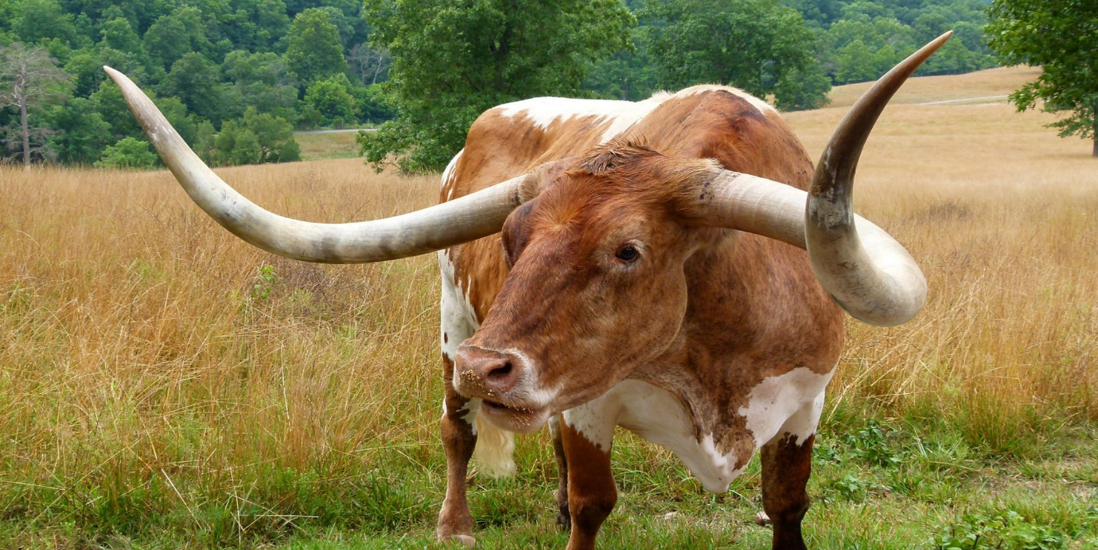

Type | Date | Total (1,000 head) | Value per Head | Total Value (1,000 dollars)
Breeding Hogs | 12/01/2020 | 2 | $108 | 216
Market Hogs | 12/01/2020 | 7 | $108 | 756
Pigs | 12/01/2020 | 3 | (D) | (D)
Beef Cows | 01/01/2021 | 14 | $1000 | 14,000
Milk Cows | 01/01/2021 | 120 | $1000 | 120,000
All Cattle and Calves | 01/01/2021 | 245 | $1000 | 245,000

\

Special Commodities

Vermont has been the leading producer of Maple Syrup in the United States for the past three years.
Maple Syrup Taps, Yield, and Production – Vermont versus United States
Location | Number of Taps  (1,000 taps) |  |  | Yield per Tap  (gallons) |  |  | Production  (1,000 gallons)
 | 2018 | 2019 | 2020 | 2018 | 2019 | 2020 | 2018 | 2019 | 2020
Vermont | 5,670 | 6,000 | 6,150 | 0.342 | 0.345 | 0.361 | 1,940 | 2,070 | 2,220
United States | 13,844 | 13,390 | 13,510 | 0.303 | 0.312 | 0.324 | 4,199 | 4,180 | 4,372

Maple Syrup Bulk Price
Bulk Price: All Grades
Year | Dollars per Pound | Dollars per Gallon
2018 | 2.20 | 24.20
2019 | 2.20 | 24.20

Fun Fact…
In 2020, Vermont created 51% of
the total United States production
of maple syrup!

Did You Know?
In the United States during 2020, Vermont ranked 8th for total
certified organic farms and 7th for total certified organic farm
acreage.

Economics
Cash Receipt Commodity  2019 | State Receipts  (1,000 Dollars) | Share of State Receipts  (Percent) | Cumulative Receipt Shares (Percent, Rounded) | U.S. Receipts (Million Dollars, Rounded) | Share of U.S. Receipts (Percent, Rounded)
Dairy Products | 514,752 | 65.0 | 65.0 | 40,498 | 1.3
Misc. Crops | 107,679 | 13.6 | 78.0 | 22,073 | 0.5
Cattle and Calves | 67,617 | 8.5 | 87.1 | 66,239 | 0.1
Maple Products | 57,960 | 7.3 | 94.4 | 129 | 44.8
Hay | 16,033 | 2.0 | 96.4 | 7,595 | 0.2
Turkeys | 13,696 | 1.7 | 98.2 | 4,304 | 0.3
All Other Products | 8,958 | 1.1 | 99.3 | 5,992 | 0.2
Chicken Eggs | 3,361 | 0.4 | 99.7 | 7,705 | 0.0
Honey | 1,250 | 0.2 | 99.9 | 306 | 0.4
Hogs | 819 | 0.1 | 100.0 | 22,015 | 0.0
Wool | 35 | 0.0 | 100.0 | 45 | 0.1
Farm Chickens | 15 | 0.0 | 100.0 | 38 | 0.0
Total | 792,174 | 100.0 | 100.0 | 369,321 | 0.2
Cash Receipts

References

Number of Farms and Land in Farms (2020 NG Farms and Land in Farms.pdf (usda.gov))
Field Crops (Northeast CropProd Jan21.pdf (usda.gov))
Vegetable Data: February 2020 New England Vegetable Report (https://www.nass.usda.gov/Statistics_by_State/New_England_includes/Publications/Current_News_Release/2020/Feb%202020%20New%20England%20Vegetable%20Report.pdf)
Floriculture and Nursey Crops (https://quickstats.nass.usda.gov/)
Fruit Data: May 2021 Fruit and Berry Report
(New England 2020 End of Season Fruit Report.pdf (usda.gov)
Honey (https://quickstats.nass.usda.gov/)
Dairy (https://quickstats.nass.usda.gov/)
Livestock (Northeastern Region Cattle Report 2021.pdf (usda.gov)
Special Commodities (https://quickstats.nass.usda.gov/)
Economics (Cash receipts by State (usda.gov))
Other Data: NASS Quick Stats (https://quickstats.nass.usda.gov/)
Images (https://www.bing.com)

